**Cardinal O’Connell Drop off and Pick up Procedure**

**Drop off begins at 9:10 AM and 1:00 PM**

**Dismissal begins at 11:30 AM and 3:20 PM**

**Walking your child to school:**

Walk down Carter St. using the sidewalk and keep right, walking along the fence to the front gate. Please bring your child to the front door of the building and a staff member will bring your child in to meet their classmates in the gym.

**Driving your child to school:**

**DO NOT PARK AND WALK from any of the streets surrounding the school – including Carter St., Carter Ave. and Livingston St. Please follow the outlined protocol below.**

Pull to the right on Carter Ave and join the carpool lane. Staff will be at the side gates to greet children and walk them into the side entrance. Please follow these procedures when dropping off or picking up your child:

1. Please post your child’s name placard on the passenger window or dashboard.
2. Pull up along the fence on Carter Ave and stay in the carpool lane on the right inside the cones to allow traffic to pass on the left.
3. If your car is the first in line, pull all the way up to the **end of the fence.**
4. Pull up as far as possible to allow room for more cars.
5. The first **7 cars only** will unload or load at a time.
6. Walk your child from your car to the gate during drop off.
7. Escort your child from the gate to your car during dismissal.
8. **DO NOT** pull around cars in front of you in the carpool lane.
9. Wait for all cars to unload or load and pull forward when directed to do so by school staff.

***Students will only be released to a parent/guardian or to a person listed on their emergency form. Changes to emergency forms need to be communicated to the front office. During the first few weeks of school, adults will need to show their ID when picking up until the staff learns who you are. New people picking up throughout the year will need to show their ID.***

**Buses:**

Buses unload at the front of the school on Carter St. Buses exit the bus lane via Livingston St; please ensure that your car does not block the buses from exiting. Do not attempt to pass buses that are parked. You will be able to pull up when the buses exit.

**Students Arriving after drop off times:**

Students arriving after 9:20 or 1:10 should be brought in through the main entrance on Carter St. and ring the bell. School staff will greet you; have you sign your child into school and they will escort your child to their classroom.

**Parking for other purposes:**

If you are coming to school for another purpose not during drop off and dismissal times, such as a meeting, dismissing your child early or picking up your child if they are sick, please park behind the school on Carter Ave or on Livingston St.

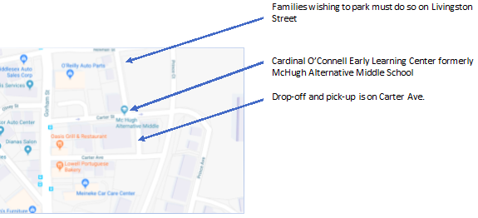

**Important Safety Information:**

* Please do not enter the playground during drop-off or pick-up.
* **DO NOT** leave students unattended in the school yard prior to 9:10 AM. Adult supervision is not available at that time.
* Please refrain from beeping car horns. Staff work as quickly and safely as possible during drop-off and pick-up.
* **PLEASE** use caution when driving in a school zone!
* Please **do not park on either side of the building on Carter Ave**. It is used **only for drop-off and pick-up.**